
October 2023
Dear Special Friends,
Good afternoon today, on Monday, October 15, 2023, while I’m ministering in Lusaka, capital of Zambia, in Southern Africa. I arrived from Lagos, Nigeria, where I’ve lived so many, many years years, a few days ago. It’s my usual time every year to come to five different countries for two months. I’ll be in Zambia, Zimbabwe, Eswatini, Botswana, and South Africa till the first part of December.
Thanks so much for always praying for me, as so many of you do, and for giving your offerings, as that’s also a great blessing to me! I always pray for you, too!
Some of you will soon receive my latest printed newsletter, as they’ll be mailed out to friends in the U.S., Europe, and Asia soon. I’m also sending the newsletter as an attachment to this monthly E-mail update, as well as personally handing it to friends everywhere I minister, too!
The beautiful, colorful “Thought for the Day” calendar for 2024 is ready, and it’s the 33rd edition, always printed in Nigeria! If you’re giving it regularly in the U.S., you should receive a complimentary copy in the mail in November or early December, so please be watching for it! I’ll also have them with me everywhere I minister, too!
You can order extra copies in the U.S., by writing to my U.S. address, and sending $5.00 per copy, plus postage. I also send the present page of the calendar as an attachment to my monthly E-mail updates, too.
Jesus is touching people, and there’s always testimonies to share! A man in Nigeria, after I ministered and then prayed for people, came to me afterwards, telling me he had suffered from a stroke, and was learning to walk again. He showed me how he could walk so much better, after I prayed for him!
Yesterday, I was praying for people at the end of the service, and a lady came to me, telling me that her hands and fingers had been so very painful all the time, as a result of chemotherapy treatments. All the pain was gone, and she was praising God!
In Nigeria, a bishop came to see me, and reminded me that we had prayed for him so many years ago (at least 28 years). What my husband and I shared that day had changed his life, when he was a student in Bible School, even ready to quit ministry.
He had a stroke two years ago, and was paralyzed, even bedridden, and had to be carried around. He was always listening to messages about healing on DVD’s and TV almost all day, every day. He was instantly healed, when a pastor on one of them pointed to the camera, and said, “Get up and walk, in the name of Jesus!”
He sang and danced for me that day in my house, after walking by himself up the stairs! Healing is real, and Jesus is real, too!
The man who’s a printer in Nigeria, and has printed all our newsletters, envelopes, etc., for over thirty years, was very discouraged, even almost ready to quit. His business had gone down to almost nothing, and he talked about closing his shop.
I prayed for him so many times, and a few weeks ago, he came with a very big smile! God had helped him to move his printing press, plus all his equipment, to the back of his friend’s shop in a different area, and a miracle had happened! People began coming again, and he was getting printing jobs almost every day! God changed his story, and He can do the same for you, too! May God change your story!
All the work in northern Ghana to help the pastors build churches in the villages and towns continues every day! The roof is on at Kori (No. 128), the roof is getting on at Ark of Salvation Church in Walewale (No. 129), and at Kasapue (No. 130). At Bootinga and Nsunia, the plastering is finished, while at Gbanyanmi and Woribogu, they’re putting in doors and windows, with plans to start plastering, when the rains stop, so the big trucks can get there with heavy loads of sand, bags of cement, etc.
Thanks so much for your support, as we do the work of God in Africa!
Love, Doris Hokett

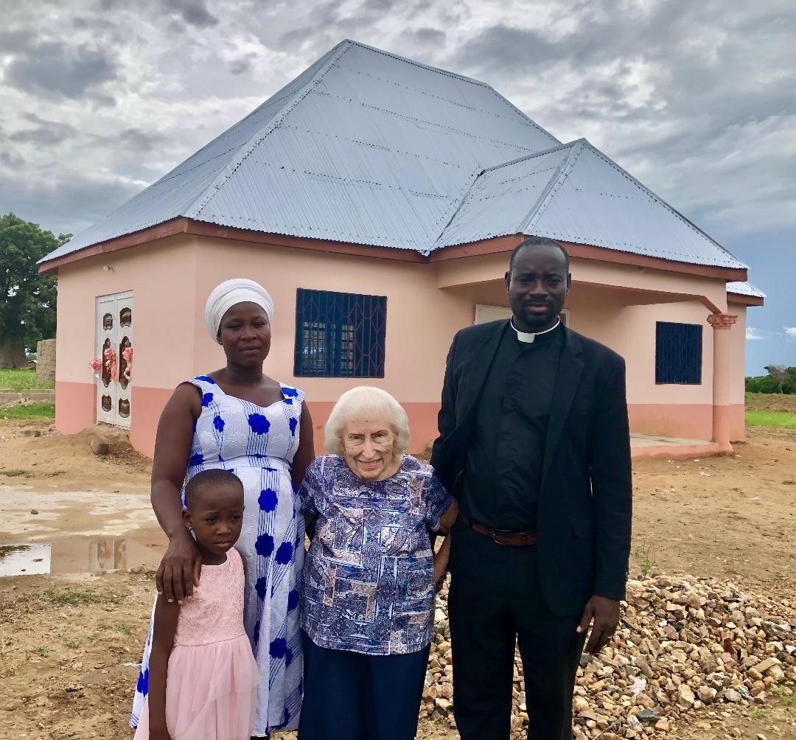
Ngondema Church

